**PROCESS TO ENABLE DEBUG MODE IN INTELLIJ**

Step 1: - Add the below property to setenv.bat file.

**set JPDA_SUSPEND=y**

Step 2: - Click Run 🡪 Edit Configurations

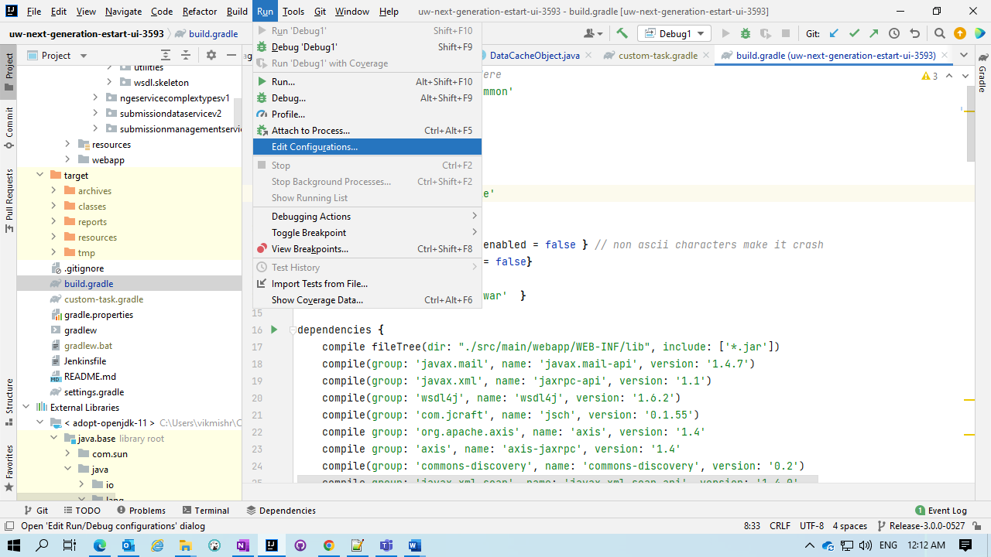

Step 3: - Click on **Add New Configuration.**

Step 4: - Click on **Remote/Remote JVM Debug**.

Step 5: - Change the name.

Step 6: - Change the port no to “**8000**”.

Step 7: - Change the Use Module Classpath to “**Project Name**” like for NgeUI “**uw-next-generation-estart-ui-3593**”.

Step 8: - Click **Apply** and then **Ok**.

* **Steps to Start the Debug mode**

Step 1: - Start the server.

Step 2: - When you get the console Up and see the message “**Listening for transport dt_socket at address: 8000**”.

Step 3: - Go to the drop down and select Debug Option.

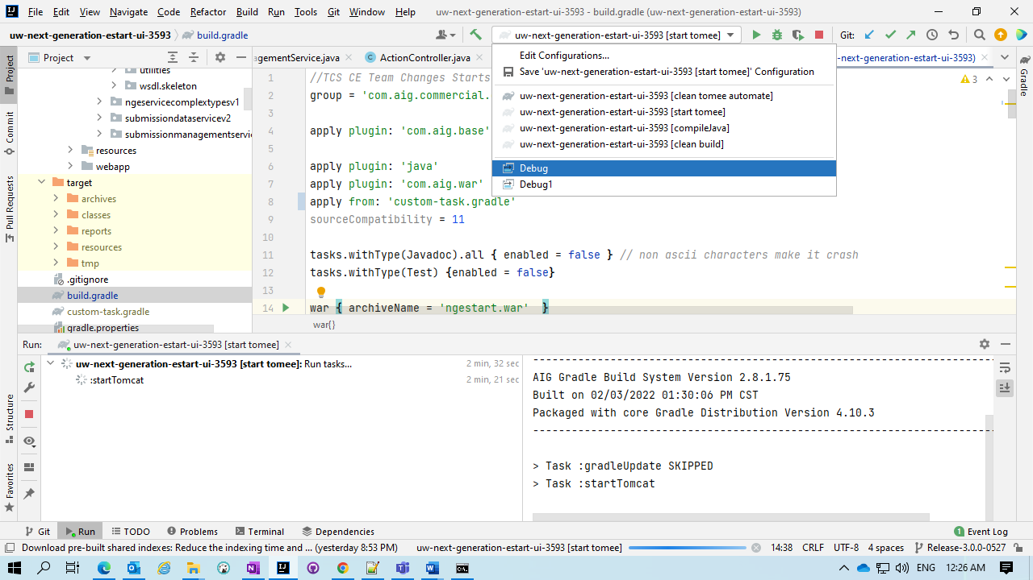

Step 4: Now Click on the **Bug icon** to start the Debug Mode.

